FLORIDA LEATHERSIR LEATHERBOY and
FLORIDA COMMUNITY BOOTBLACK
June 15-18, 2017

“Together As One”
Flamingo Resort
4601 34th Street S, St Petersburg, Florida 33711

Thank you for taking a moment to look over the advertising information for Florida LeatherSIR, Leatherboy and Florida Community Bootblack 2017!

We are very excited about what this year has to offer.

Florida LeatherSIR, Leatherboy and Florida Community Bootblack event weekend will be held in St. Petersburg Florida at the Flamingo Resort the weekend of June 15-18, 2017

With a dedicated and distinguished history, advertising with FLSb-FCBB will give you the opportunity to reach out to a significant number of individuals in the Regional leather/fetish/SM community.

You can be among the many businesses and organizations included in this year’s Program Book.

Apply now! Our advertising deadline is rapidly approaching and we want to make sure you have the opportunity to reach out to and support this important market!

The deadline for submission of your advertising logo is May 1st, 2017

Please review the advertising application on the following page and please do not hesitate to contact me if you have any questions.

Sincerely,

Bill Hoeppner
Producer
FLSb - FCBB 2017
b.hoeppner2010@gmail.com

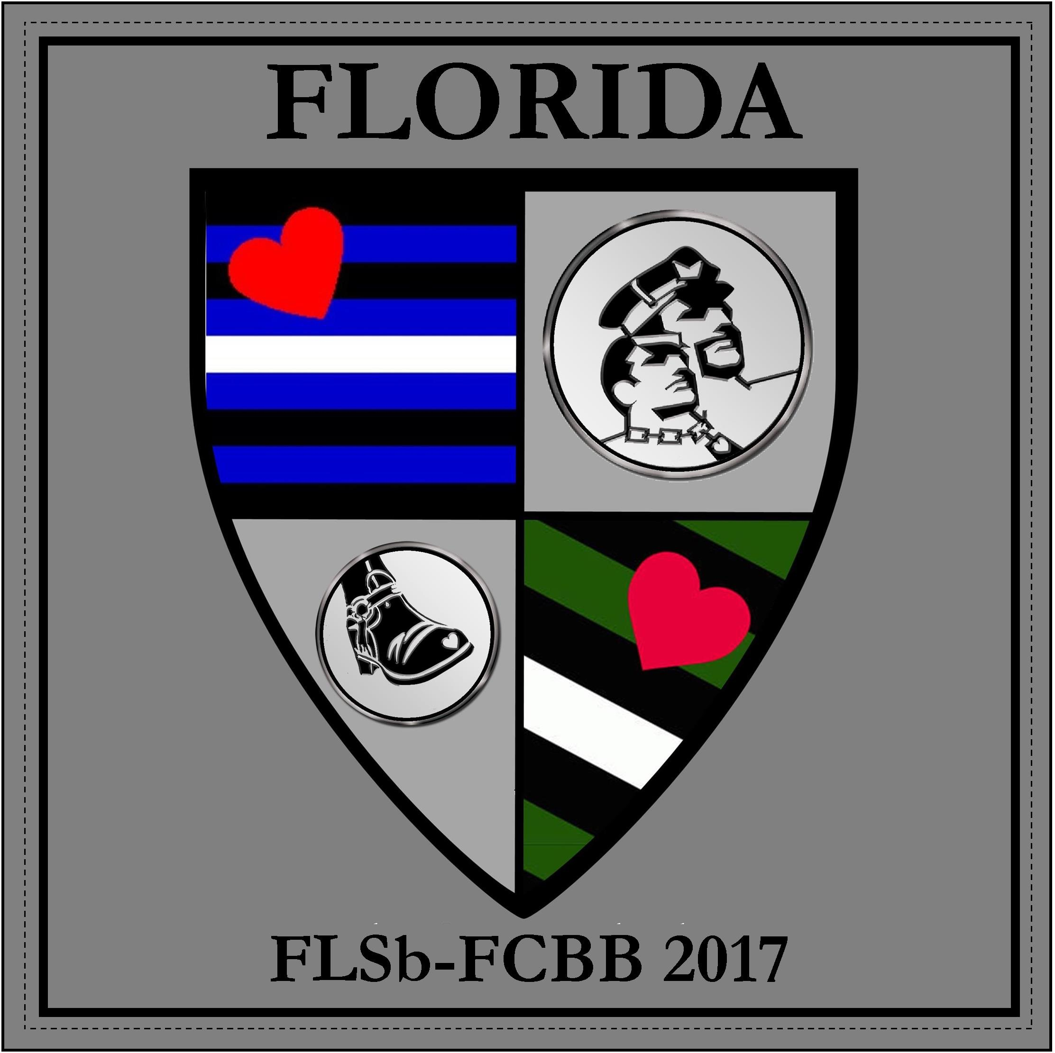
FLORIDA LEATHERSIR LEATHERBOY and
FLORIDA COMMUNITY BOOTBLACK
June 15-18, 2017

“Together As One”
Flamingo Resort
4601 34th Street S, St Petersburg, Florida 33711

ADVERTISING INFORMATION

Name of business or organization: _______________________________________________

Contact person: ___________________________ Phone: ( ) _______________________

Email: _____________________________________________________________________

Address: ___________________________________________________________________

City: __________________________ State:_______________________ Zip: ____________

I have emailed a digital logo to b.hoeppner2010@gmail.com: Yes__ No__

Logos and ads must be submitted to b.hoeppner2010@gmail.com by the deadline of May 1st, 2016
to be included on FLSb-FCBB program book.

Ads will be accepted in .PDF or .JPG format (must be 300DPI). Full bleeds are allowed.

Advertising Cost (check one)

___ Inside Front Cover Size of Ad: 5 1/2 x 8 1/4 (SOLD) Cost - $150.00

____ Back Cover Size of Ad: 5 1/2 x 8 1/4 (SOLD) Cost - $150.00

___ Inside Back Cover Size of Ad: 5 1/2 x 8 1/4 (SOLD) Cost - $150.00

____ Full Page Size of Ad: 5 1/2 x 8 1/4 Cost - $100.00

____ Half Page Size of Ad: 5 1/2” x 4 1/8” Cost - $50.00

____ Promotional materials stuffed into registration bags Cost - $25.00

Total Amount Enclosed $

Inside front / inside back covers and back cover is on first come basis.
Please remember to send your logos and payment to arrive before May 1st, 2017
for inclusion on FLSB-FCBB program book. Advertising is not considered final until payment is received. Mail a check or money order to: FLSb - FCBB 2017 c/o Bill Hoeppner 1637 NE 9th Street, Ft Lauderdale, Florida 33304

