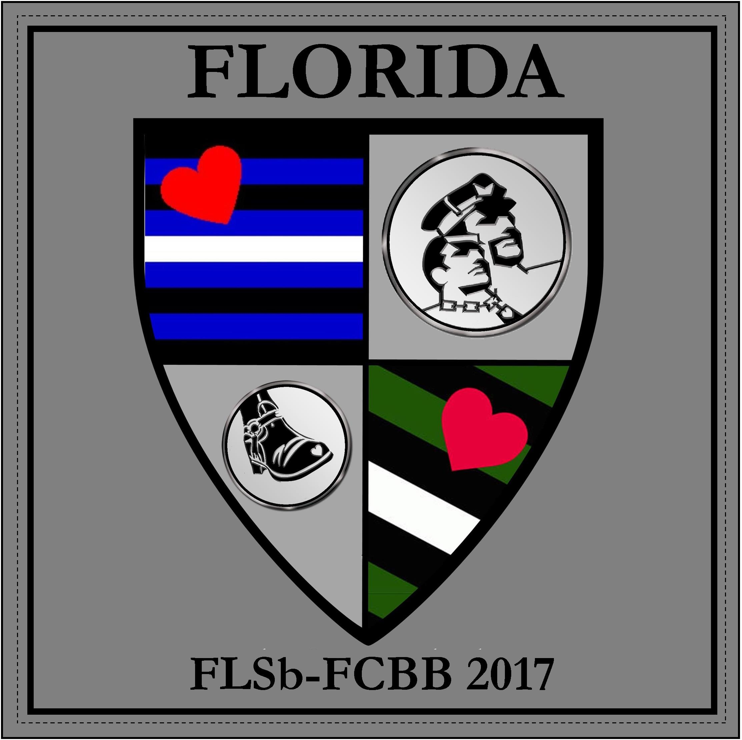
FLORIDA LEATHERSIR LEATHERBOY and
FLORIDA COMMUNITY BOOTBLACK
June 15-18, 2017

“Together As One”
Flamingo Resort
4601 34th Street S, St Petersburg, Florida 33711

VENDORS APPLICATION

Name of business or organization: _______________________________________________

Contact person: ___________________________ Phone: ( ) _______________________

Email: _____________________________________________________________________

Address: ___________________________________________________________________

City: __________________________ State:_______________________ Zip: ____________

I have emailed a digital logo to b.hoeppner2010@gmail.com: Yes__ No__

Logos and ads must be submitted to b.hoeppner2010@gmail.com by the deadline of May 1st, 2016
to be included on FLSb-FCBB program book.

Ads will be accepted in .PDF or .JPG format (must be 300DPI). Full bleeds are allowed.

Advertising Included

____ Half Page Size of Ad: 5 1/2” x 4 1/8” Cost - INCLUDED

____ Promotional materials stuffed into registration bags Cost - INCLUDED
(Promotional Materials must be provided by Vendor)

Please remember to send your logos and payment to arrive before 1st, 2017. Indoor space is limited, only 8 space available.
Application is not considered final until payment is received. Mail a check or money order to:
FLSb - FCBB 2017
c/o Bill Hoeppner
1637 NE 9th Street,
Ft Lauderdale, Florida 33304

All merchandising materials including lighting must be provided by Vendor. Please also bring signage for the front windows. The signage should be approximately 3’ x 4’ - Bold Lettering and include logo and any other pertinent information, i.e., show specials etcx.

___ Inside Half Room Standard 1/2 Room Size (Approx 5’ X 15’) Cost - $75.00

____ Inside Full Room Standard 1/2 Room Size (Approx 10’ X 15’) Cost - $125.00

___ Outside Vendor Space Cost - $30.00

All Indoor space include Air-conditioning, and bathroom. Vendor rooms are located on the ground floor poolside between the Cabana Bar, The Hurricane Bar and the Code Bar. As this Resort is open to the general public in addition to our attendees, the night time traffic is a more diverse group of guests.

Total Amount Enclosed $ _______________

Vendor Rooms are available for Set up after 4:00pm on Thursday, June 15. If you would like you are able to be open for business on Thursday night for early arrivals until 2:00am when the bars close.

Vendor spaces should be open:

Friday, June 16: 12:00 noon and can remain open all day until the bars close at 2:00am if vendor chooses.

Saturday, June 17 11:00am and can remain open all day until the bars close at 2:00am if vendor chooses.

Sunday: 12:00 noon and can remain open until end of Poolside T-dance at 6:00pm.

If you have any questions, please feel free to contact me.

With Honor and Respect
Your Brother in Leather

Bill Hoeppner
Regional Producer
FLSb-FCBB 2017
305.213.8706
b.hoeppner2010@gmail.com

